**Activity 1. Borders**

Write CSS rules to the HTML code to get the next result

<https://codepen.io/paqui-molina/pen/KrVyGd>

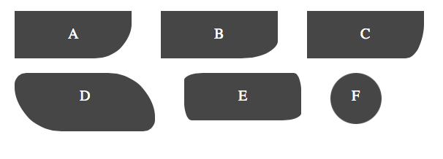**Activity 2. Shadows**

Write CSS rules to the HTML code to get the next result

[**https://codepen.io/paqui-molina/pen/vQLWvV**](https://codepen.io/paqui-molina/pen/vQLWvV)

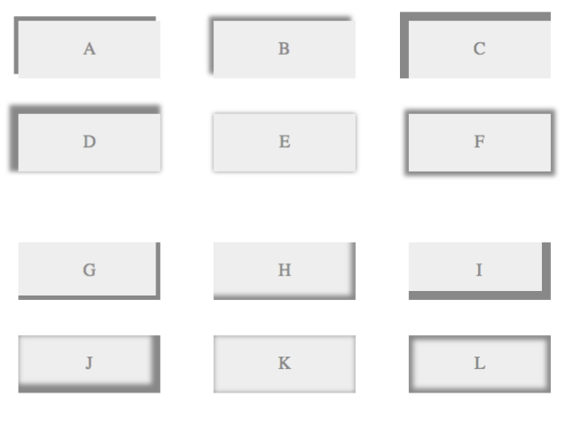

**Activity 3. Shadows**

Write CSS rules to the HTML code to get the next result

<https://codepen.io/paqui-molina/pen/yQePma>

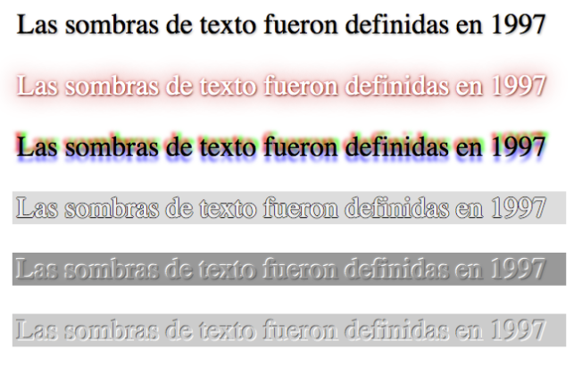

**Activity 4. Gradients**

Make an HTML document where you have a centered div container, with margins of 50 pixels in all directions and dimensions width 400 pixels and height 200 pixels. Create an effect, like in the following image, inside that DIV using the linear-gradient CSS property.

